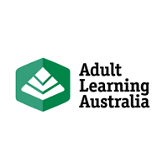
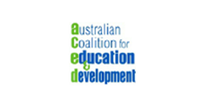
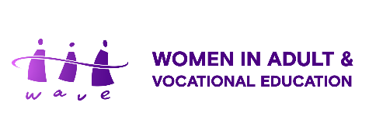
Transforming Education and Training in Australia:
Challenges and Opportunities
Policy Forum Statement
Release date: 15 February 2023

Introduction
We, the members of the Australian Coalition for Education and Development, specifically, Adult Learning Australia (ALA), Women in Adult and Vocational Education (WAVE) and the EU Centre of Excellence at RMIT University, organized a Policy Forum entitled: Transforming Education and Training Systems in Australia: Challenges and Opportunities on 15 February 2023 at RMIT University. Together with the LFL and the CCA, we call the attention of our policymakers, our colleagues in the field of education and lifelong learning to the following:
Statement
‘We believe that all Australians should have access to quality adult education and training when and where they need it. The Australian government is urged to take up the challenge of transforming education and training systems to ensure that all individuals, communities, and businesses can participate equally and achieve the outcomes necessary to enjoy a sustainable emerging future. Current government policies are no longer adequate to support the transformation of our societies in the face of global challenges and changes. Access and equity to lifelong learning are the keys to ensuring that no one is left behind.’
We advocate for the following actions:
Enact a National Lifelong Learning Policy
- Lifelong learning must be formalised by the Australian Government as a coherent overarching framework that embraces all education and training sectors in Australia, to enhance integration and articulation of the various education and training sectors and to provide flexible affordable and accessible learning pathways for all Australians.
- A National Lifelong Learning Policy be enacted that highlights the need for all Australians to learn and continue learning throughout life to face the challenges of the twenty-first century that recognises a life course approach and social determinants of health.
- In keeping with the Uluru Statement of the Heart, actively ensure Aboriginal and Torres Strait Islander peoples have opportunities to define self-determination in education and to engage in rich and fulfilling learning throughout their lives.
- The formal policy developed must clearly outline economic and social goals; integrate efficiency and equity; and sets out roles and responsibilities for community, business, and all levels of government. It must emphasize the life-skills required and the inter-connected pathways between learning opportunities.

Support and sustain an equitable adult and vocational education system
- The Australian government renews the Ministerial Declaration on Adult and Community Education, and outlines strategies to support Adult and Community Education organisations as they continue to deliver opportunities to many Australians, including disadvantaged learners.
- The Australian government must develop, implement, and monitor nationally consistent policies and guidelines utilising an intersectional gender equity approach that embeds equity, inclusiveness, and diversity in each and all sectors of education and training,
- Adopt policies and guidelines that create a safe and more equitable adult and vocational education system that delivers for students and learners of all abilities, communities, and industry.
- Gender disaggregated data is used to plan for and forecast labour and skills needs and, measure the effectiveness of the student’s journey and outcomes to address the inequitable nature of the vocational and adult education system and workforce.
- The Australian government must commit to developing and resourcing a national adult literacy strategy with targets and timelines.
- Develop the capacity of skills, workforce development, language literacy and numeracy and adult education sectors and systems to be more inclusive, sustainable, productive, flexible and aligned to our community needs and emerging economic, environmental & socio-cultural challenges.

Meet our international commitments to quality education and lifelong learning
- The Australian government take concrete steps to meet its international commitment to the Sustainable Development Goals, in particular SDG 4, to ensure inclusive and equitable quality education and promote lifelong learning opportunities for all. And to actively engage UNESCO and other member states to promote and implement the Marrakesh Framework for Action, 2022.

